1.6 Work Worksheet

- A crane has a cable used to lift and move various objects. The cable is 300ft long and weighs a total of 2000lbs.
- If half of the cable is currently out and needs to be retracted how much work is required to accomplish this?

I will imagine labeling the top of the chain as height 0 and the bottom as height 150.
The cable is 300ft long and weighs 2000lbs so that means that the cable weighs .
The force required to lift any cross section is:

The distance any cross section needs to be pulled is:

So the work needed for any given cross section is:

The integral we need is:

- If the cable is fully extended and is then hooked up to a 3-ton crate, how much work is required to retract the cable?

I will imagine labeling the top of the chain as height 0 and the bottom as height 300.
The force required to lift any cross section is: | The force required to lift any cross section is:
The distance any cross section needs to be pulled is: | The distance the crate needs to be pulled is:
So the work needed for any given cross section is: | So the work needed to lift the crate is:
So we set up:

- A 100ft length of steel chain weighing is dangling from a pulley.
- How much work is required to wind the chain onto the pulley?

I will imagine labeling the top of the chain as height 0 and the bottom as height 100.
The chain weighs .
The force required to lift any cross section is:

The distance any cross section needs to be pulled is:

So the work needed for any given cross section is:

The integral we need is:

- How much work is required to wind half of the chain onto the pulley?

We just need to change the bounds on our integral.
Since the entire chain moves when only half is being pulled in moving this first half of the chain being pulled in should be more work than pulling in the second half. Therefore, set the bounds to go from 50 to 100 since this will produce more work than the integral from 0 to 50.

The integral we need is:

- An 800ft cable weighs 1600lbs and is used to lift 800lbs of coal up a mine shaft which is 500ft deep. Find the work done by lifting all the coal to the top of the shaft.

I will imagine labeling the top of the cable as height 0 and the bottom as height 500 (since only 500ft of cable are needed here).
The cable is 800ft long and weighs 1600lbs so that means that the cable weighs .
The force required to lift any cross section is:

The distance any cross section needs to be pulled is:

So the work needed for any given cross section is:

The integral we need is:

- A chain lying on the ground is 10m long and its mass is 80kg. How much work is required to raise one end of the chain to a heigh of 6m?

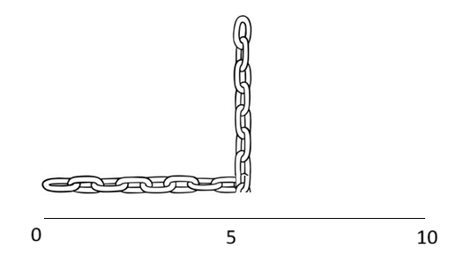
We label the chain in the following way.

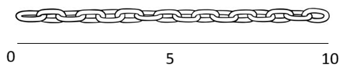

We see that the cable has a mass of .
The mass of any cross section is:
Therefore, the force required to move any cross section is:

The distance any cross section needs to be pulled is:

So the work needed for any given cross section is:

The integral we need is:

- A cylindrical tank of radius 3ft and height 10ft is half filled with water. How much work is required to pump the water out of a hole in the top of tank? (The density of water is )

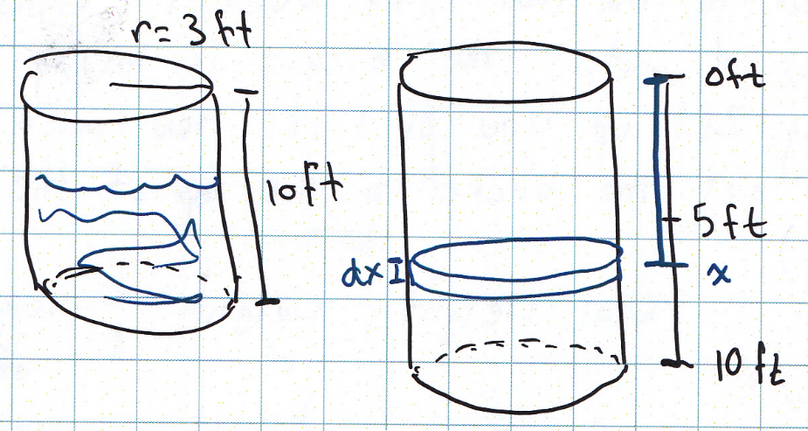

Setup:
So for a single cross section of the tank:

Therefore, we define the total work as:

OR

If we choose the bottom of the tank as height 0 then we say that:

Evaluate:

- A swimming pool is built in the shape of a rectangular prism which is 10ft deep, 15ft wide, and 20ft long.
- If the pool is filled with water to 1ft below the top, how much work is required to pump all the water into a drain at the top edge of the pool? (The density of water is )
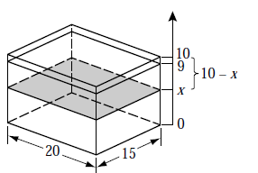
So for a single cross section of the tank:

Therefore, we define the total work as:

OR

If we choose the bottom of the tank as height 10 then we say that:

Evaluate:

- A one-horsepower motor can do 550ft-lb of work per second. What size motor is required to empty the pool in 1 hour?

To empty the tank in one hour would require
So a motor of of work per second would empty the tank in one hour.

- An inverted cone shaped water reservoir is 20m in diameter across the top and 15m in height. If the reservoir is filled to a depth of 10m, how much work is required to pump all the water to the top of the reservoir? (The density of water is .)

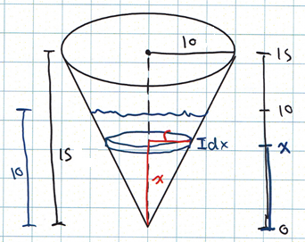
Setup:

So for a single cross section of the tank:

Therefore, we define the total work as:

Evaluate:

Note: Assigning 0 to be the top of the tank will cause you to have to rework your formula for the radius.
When 0 is the bottom of the tank the radius of the water is given by: .
When 0 is the top of the tank the radius of the water is given by: .

- The vat in the picture below contains water to a depth of 2m. Find the work required to pump all of the water to the top of the vat. (The density of water is ).
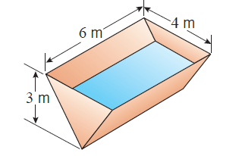
Setup:
We know that the length (from front to back) of the water is always a constant of 6m.
However, the width (from left to right) of the water is not constant. We note that by similar triangles that

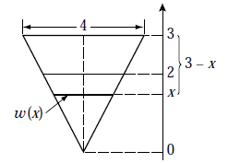
So for a single cross section of the tank:

Therefore, we define the total work as:

Evaluate:

